Luxury Serviced Studio Apartments at City

Scape Faletti’s in Lahore

City Scape Faletti’s Service Apartment is one of the most sought-after residential projects in Lahore, combining luxury living, modern design, and a prime city-center location. Strategically located near Faletti’s Hotel, Mall Road, and other major landmarks, this development provides both comfort for residents and a strong investment opportunity in serviced apartments. Whether you are a business traveler, a family, or an investor, City Scape Faletti’s Service Apartment offers the ideal blend of convenience, style, and profitability.
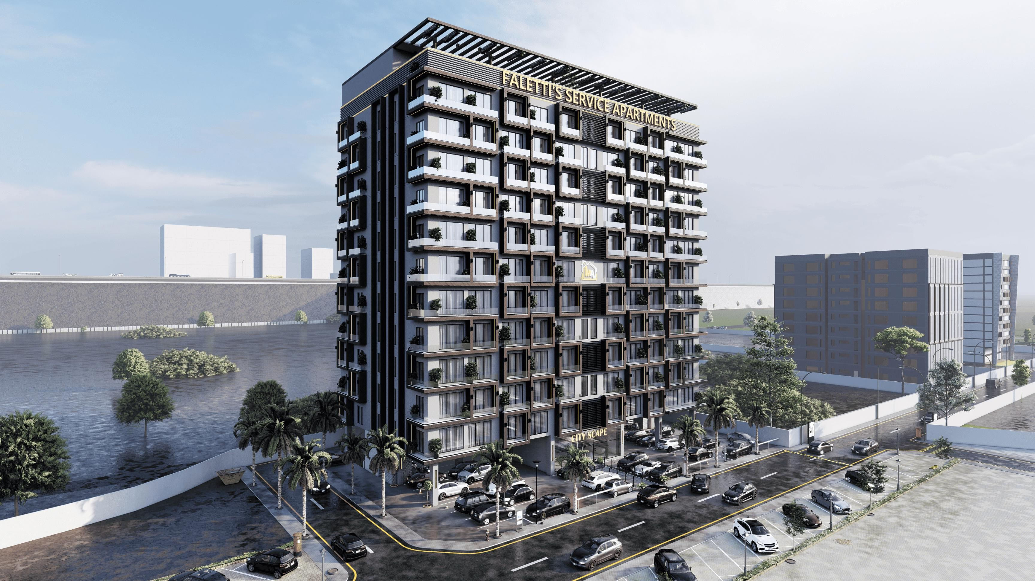

What Are Service Apartments and Why Choose Them?
Service apartments are fully furnished residential units that combine the convenience of hotel services with the privacy and flexibility of traditional apartments. Unlike standard apartments or hotels, they offer additional services like housekeeping, security, and concierge assistance, making them perfect for long stay serviced apartments Lahore.

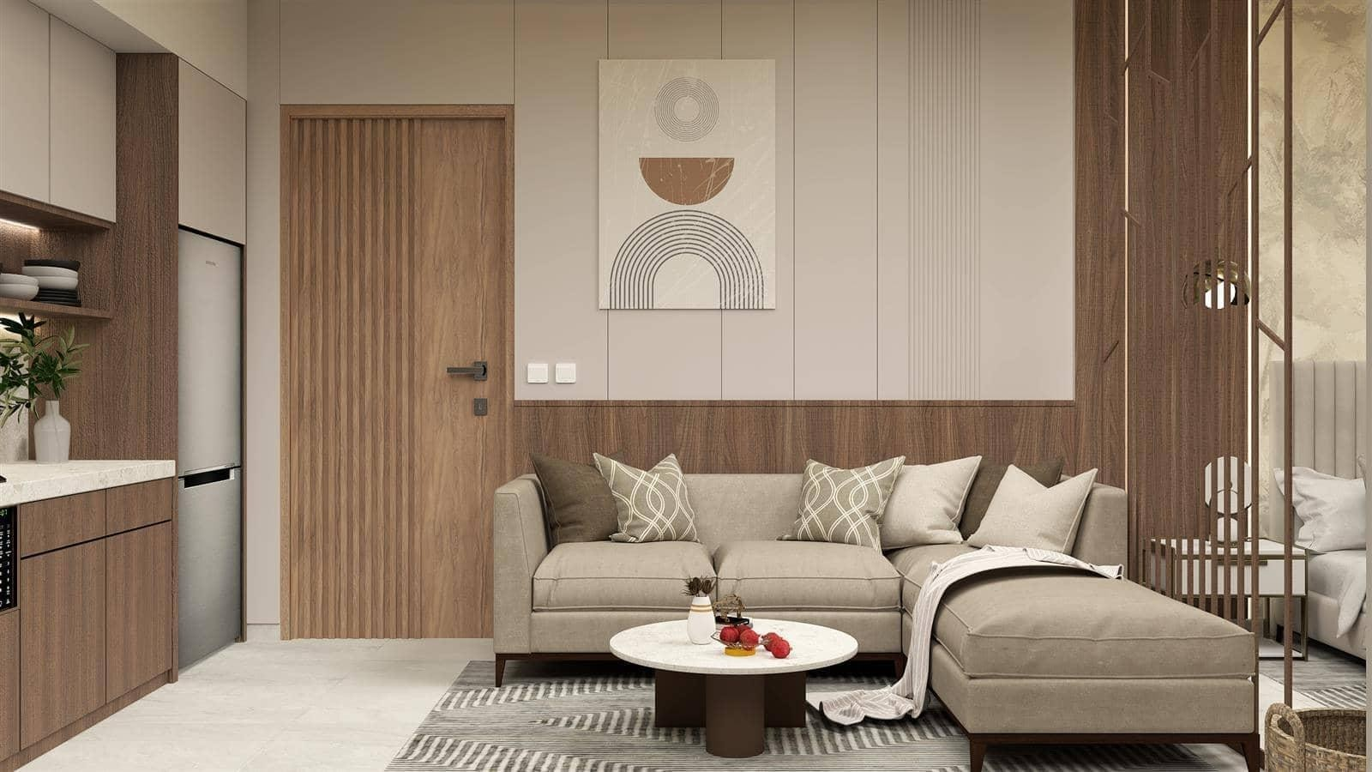

Key Benefits of Serviced Apartments:
- Fully furnished with modern furniture and appliances
- Professional housekeeping services
- 24/7 security and surveillance
- Flexible rental options for short-term or long-term stays
- Cost-effective compared to extended hotel stays
- Prime location advantages

City Scape Faletti’s Service Apartment exemplifies these benefits, providing a luxurious lifestyle with the comfort of home and professional services.

Prime Location Apartments Lahore – The Central Advantage
Location is a key factor in property value, convenience, and lifestyle. City Scape Faletti’s Service Apartment offers prime location apartments in Lahore, providing easy access to:

- Faletti’s Hotel and nearby luxury hotels
- Mall Road and major commercial hubs
- Educational institutions and colleges
- Hospitals and healthcare centers
- Restaurants, cafes, and entertainment areas
- Main roads and public transport links

Being situated in central Lahore ensures that residents enjoy connectivity, convenience, and access to essential amenities, making these apartments highly desirable for both residents and investors.

Luxury and Modern Design for Every Resident
City Scape Faletti’s Service Apartment emphasizes modern architectural design combined with luxurious interiors. Each apartment is crafted to deliver both comfort and elegance, ensuring a premium living experience.
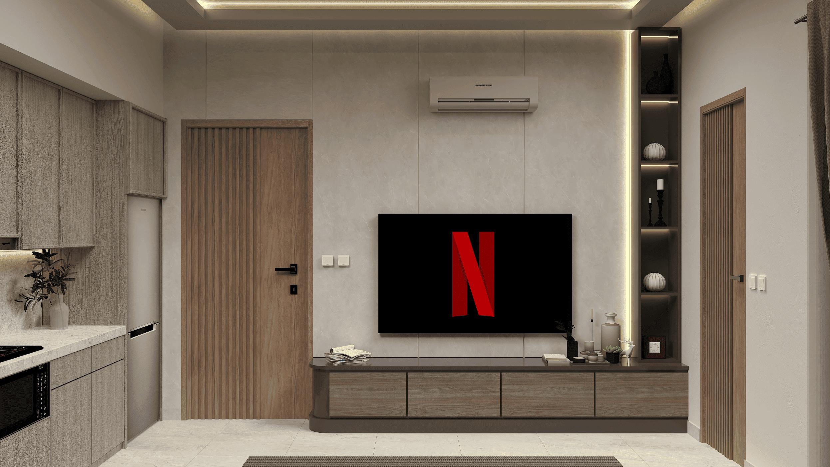

Apartment Features:
- Spacious living areas for families and professionals
- Modern kitchens with high-quality appliances
- Stylish bathrooms with contemporary fittings
- Natural lighting and ventilation
- Elegant flooring and finishing materials
- Fully furnished interiors for immediate move-in

This focus on luxury serviced apartments in Lahore ensures residents enjoy a lifestyle that matches international standards.

Fully Furnished Service Apartments Lahore
One of the major attractions of City Scape Faletti’s Service Apartment is that every unit is fully furnished. This feature makes the apartments ideal for both business travelers and families, offering a hassle-free living experience.

Furnishing Includes:

- Comfortable beds and wardrobes
- Sofas, dining tables, and seating areas
- Kitchen appliances such as ovens, refrigerators, and microwaves
- Air conditioning and heating systems
- Lighting fixtures and decor accessories

Fully furnished apartments not only save residents the time and expense of buying furniture but also ensure a consistent, luxurious aesthetic across all units.

Hotel-Style Amenities and Services
City Scape Faletti’s Service Apartment provides hotel-style services that make daily living convenient and stress-free. These amenities distinguish serviced
apartments from standard residential options, offering both comfort and peace of mind.

Premium Services:
- 24/7 security and surveillance
- Daily housekeeping services
- High-speed internet and Wi-Fi connectivity
- Backup electricity and water supply
- Elevator and parking facilities
- Concierge assistance and maintenance services

These services cater to service apartments for business travelers in Lahore, families, and long-term residents, ensuring a premium living experience without compromise.

Long Stay Serviced Apartments Lahore – Perfect for Extended Visits
For those seeking extended accommodation, long stay serviced apartments in Lahore provide significant advantages over hotels. City Scape Faletti’s Service Apartment is designed to meet the needs of long-term residents while maintaining luxury and convenience.

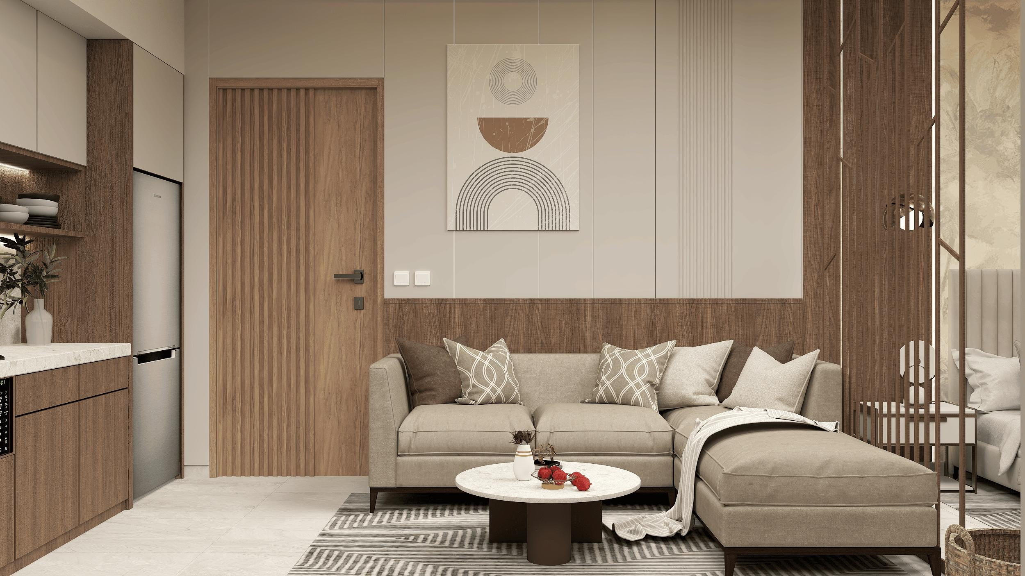

Advantages of Long Stay Apartments:
- Cost-effective compared to hotel rates for long durations
- Greater privacy and freedom
- Fully equipped kitchen and living areas
- Flexible lease terms
- Home-like environment with professional services

This makes City Scape Faletti’s Service Apartment a preferred choice for expatriates, corporate professionals, and families relocating to Lahore.

Business Traveler-Friendly Apartments
City Scape Faletti’s Service Apartment is also tailored for service apartments for business travelers in Lahore. Its central location, modern facilities, and professional services make it the perfect choice for corporate clients.

Benefits for Business Travelers:
- Quick access to commercial hubs and business districts
- High-speed internet and workspace areas
- Short-term rental options for business trip
- Peaceful and secure environment for focused work
- Concierge services for bookings, transportation, and logistics

Business travelers benefit from the convenience, flexibility, and comfort that these serviced apartments provide, ensuring a seamless stay.

Investment Opportunity in Serviced Apartments
Investing in serviced apartments has become a lucrative option in Lahore, and City Scape Faletti’s Service Apartment represents one of the strongest investment opportunities in serviced apartments.

Why Invest?
- High rental demand from business travelers and tourists
- Potential for long-term capital appreciation
- Prime location increases property value over time
- Professional management ensures hassle-free investment
- Flexible rental options to maximize ROI

Investors can enjoy both steady rental income and long-term growth, making serviced apartments a smart addition to any real estate portfolio.

Luxury Serviced Apartments in Lahore – Amenities That Matter
City Scape Faletti’s Service Apartment emphasizes a lifestyle that goes beyond just living space. These luxury serviced apartments in Lahore include amenities that enhance comfort, convenience, and leisure.

Lifestyle Amenities:
- Modern fitness center and gym
- Rooftop lounge and relaxation areas
- High-speed elevators
- Secure parking for residents and visitors
- 24/7 security and surveillance
- Backup power and water systems

By offering these amenities, the apartments ensure that residents enjoy a premium, hassle-free lifestyle.

Comparisons: Serviced Apartments vs Hotels
When considering accommodation options in Lahore, many compare serviced apartments with hotels. Here’s why serviced apartments like City Scape Faletti’s are superior:

Feature | Serviced Apartments | Hotels
Living Space | Spacious | Limited
Privacy | High | Moderate
Kitchen | Fully equipped | Rarely available
Rental Flexibility | Short & long-term | Mostly short-term
Cost for Long Stay | Affordable | Expensive
Amenities | Hotel-style + home comfort | Hotel only

Serviced apartments are especially cost-effective for long stays, making them ideal for business travelers, families, and expatriates.

Target Audience – Who Should Choose These Apartments?
City Scape Faletti’s Service Apartment is designed for a variety of residents:

1. Business Travelers – Convenient, professional, and connected
2. Families – Spacious, safe, and fully serviced
3. Tourists – Central location and comfort
4. Investors – High rental demand and capital appreciation
5. Expatriates – Long stay options with fully furnished apartments
6. No matter the purpose, these serviced apartments offer unmatched convenience and lifestyle benefits.

Lifestyle Advantages of Prime Location Apartments Lahore
Choosing prime location apartments in Lahore provides unmatched lifestyle and investment benefits. Residents of City Scape Faletti’s Service Apartment enjoy:

- Short commute times to offices and commercial areas
- Easy access to shopping and dining options
- Proximity to cultural and recreational centers
- Prestige associated with a central, high-demand area
- This combination of luxury, convenience, and location makes it an ideal residential choice.

Future Growth & Development Potential
Lahore’s real estate market continues to expand, and serviced apartments in prime locations are increasingly in demand. City Scape Faletti’s Service Apartment is positioned to benefit from:

- Urban development projects
- Infrastructure improvements
- Growing commercial activity in central Lahore
- Rising demand for premium, serviced accommodation
- Investors and residents alike stand to benefit from this long-term growth.

Frequently Asked Questions (FAQ)

What makes City Scape Faletti’s Service Apartment unique?
City Scape Faletti’s combines luxury living, fully furnished apartments, prime location, and hotel-style services, making it stand out from other residential projects in Lahore.

Are these apartments suitable for long-term stays?
Yes, these are long stay serviced apartments in Lahore, perfect for professionals, families, and expatriates.

Can investors earn rental income from these apartments?
Absolutely. With high demand from business travelers and tourists, these apartments offer strong rental returns and investment opportunities.

Are the apartments fully furnished?
Yes, all apartments are fully furnished with modern furniture, appliances, and decor.

Who should consider living here?

Business travelers, families, tourists, and real estate investors will find these apartments ideal.

